**EduConnect: Bringing Learners and Knowledge in the E-Learning Era**

A

Project Report

Submitted in partial fulfillment of the requirement for the award of degree of

### Bachelor of Technology

In

### Computer Science & Engineering

Submitted to

### RAJIV GANDHI PROUDYOGIKI VISHWAVIDYALAYA, BHOPAL (M.P.)



**Guided By Submitted By**

Prof. Leeladhar Chourasiya KrishnaBhawsar(0827CS211132) Krishna Gupta(0827CS211069)

Jigyansh Sisodiya(0827CS211111)

Jaydeep Malvya (0827CS211109)

DEPARTMENT OF COMPUTER SCIENCE AND ENGINEERING

ACROPOLIS INSTITUTE OF TECHNOLOGY & RESEARCH, INDORE (M.P.) 452020

**2023-2024**

### Declaration

I hereby declared that the work, which is being presented in the project entitled **EduConnect** partial fulfilment of the requirement for the award of the degree of **Bachelor of Technology**, submitted in the department of **Computer Science and Engineering** at **Acropolis Institute of Technology & Research, Indore** is an authentic record of my own work carried under the supervision of **Prof. Leeladhar Chourasiya**. I have not submitted the matter embodied in this report for award of any other degree.

Kunal Yadav (0827CS211132)

Dev Vyas (0827CS211069))

Ishant Mandloi (0827CS211105)

Jay Sharma (0827CS211108)

Prof. Leeladhar Chourasiya

Supervisor

### Project Approval Form

I hereby recommend that the project **EduConnect** prepared under my supervision by Kunal Yadav (0827CS211132)**,** Dev Vyas(0827CS211069)**,** Ishant Mandloi (0827CS211105)  **&** Jay Sharma (0827CS211108)be accepted in partial fulfillment of the requirement for the degree of Bachelor of Engineering in Computer Science & Engineering.

Prof. Leeladhar Chourasiya

#### Supervisor

Recommendation concurred in 2023-2024

Prof. Leeladhar Chourasiya

#### Project Incharge

Prof. Leeladhar Chourasiya

#### Project Coordinator

**Acropolis Institute of Technology & Research**

### Department of Computer Science and Engineering



**Certificate**

The project work entitled **EduConnect** submitted by **Kunal Yadav(0827CS211132), Dev Vyas(0827CS211069),**

### Ishant Mandloi(0827CS211105) & Jay Sharma(0827CS211108)

is approved as partial fulfillment for the award of the degree of Bachelor of Technology in Computer Science and Engineering by Rajiv Gandhi Proudyogiki Vishwavidyalaya, Bhopal (M.P.).

### Internal Examiner External Examiner

Name:………………. Name: ……………..

Date: …./…/……….. Date: …./…/………..

# Acknowledgement



We thank the almighty Lord for giving me the strength and courage to sail out through the tough and reach on shore safely.

There are number of people without whom this project's work would not have been feasible. Their high academic standards and personal integrity provided me with continuous guidance and support

We owe a debt of sincere gratitude, deep sense of reverence and respect to our guide and mentor ***Prof. Leeladhar Chourasiya*,** Professor, AITR, Indore for his motivation, sagacious guidance, constant encouragement, vigilant supervision and valuable critical appreciation throughout this project work, which helped us to successfully complete the project on time.

We express profound gratitude and heartfelt thanks to ***Prof. Kamal Kumar Sethi***, Professor & Head CSE, AITR Indore for his support, suggestion, and inspiration for carrying out this project. I am very much thankful to other faculty and staff members of CS Dept, AITR Indore for providing me all support, help and advice during the project. We would be failing in our duty if do not acknowledge the support and guidance received from **Dr S C Sharma**, Director, AITR, Indore whenever needed. We take the opportunity to convey my regards to the management of Acropolis Institute, Indore for extending academic and administrative support and providing us with all necessary facilities for the project to achieve our objectives.

We are grateful to **our parents** and **family members** who have always loved and supported us unconditionally. To all of them, we want to say “Thank you”, for being the best family that one could ever have and without whom none of this would have been possible.

**Kunal Yadav(0827CS211132)**

**Dev Vyas(0827CS211069)**

### Ishant Mandloi(0827CS211105)

### Jay Sharma(0827CS211108)

**Abstract**

This report delves into the development and implementation of an innovative blogging platform designed to enhance online content creation and user engagement. Traditional blogging platforms, while facilitating content creation, often fall short in fostering meaningful interactions between creators and their audiences. The proposed platform addresses this gap by integrating advanced multimedia tools, interactive features, and user-centric design principles. This paper outlines the objectives, methodology, and anticipated outcomes of the project, supported by a comprehensive review of existing literature and current technologies in the field. By prioritizing user engagement, collaborative features, and ease of use, the platform aspires to redefine the blogging landscape and create vibrant online communities. Through methodical planning, iterative development, and rigorous testing, this platform aims to offer a dynamic, engaging, and user-friendly experience for both content creators and their audiences.

**Key words :** User engagement, multimedia tools, interactive features, user-centric design etc.

*"Every day is a journey, and the journey itself is home."*

*– Basho*



# List of Figures

Figure: Data Flow Diagram Figure: Entity Relational Diagram Figure: Activity Diagram Figure: Use Case Diagram

# List of Abbreviations



***Abbr1:*** HTML- HyperText Markup Language

***Abbr2:*** CSS – Cascading Style Sheets

***Abbr3:*** JS- JavaScript ***Abbr4:*** Node.js -Java Script

***Abbr5:*** IDE- Integrated Development Environment ***Abbr6:*** HTTP- Hypertext Transfer Protocol ***Abbr7:*** DB- Database

***Abbr8:*** UML- Unified Modeling Language

# Table of Contents

###### CHAPTER 1 . INTRODUCTION 1

* 1. Overview 1
  2. Background and Motivation 2
  3. Problem Statement and Objectives 2
  4. Scope of the Project 3
  5. Team Organization 5
  6. Report Structure 5

###### CHAPTER 2 . REVIEW OF16

###### LITERATURE..............................................

* 1. Preliminary Investigation17

......................................................

* + 1. Current System 17
  1. Limitations of Current System17

..............................................

* 1. Requirement Identification and Analysis for Project 17
     1. Conclusion 18

|  |  |  |  |  |
| --- | --- | --- | --- | --- |
| **CHAPTER 3 .** | **PROPOSED**  **......................................................** | | **SYSTEM** | **1**8 |
| 3.1 | The  ....................................................................... | | Proposal | 18 |
| 3.2 | Benefits of the  System........................................ | | Proposed | 18 |
|  |  | | |  |
| 3.3 | Feasibility Study .............................................................. | | | 19 |
|  | 3.4.  1 | Technical  ................................................................. | | 19 |
|  | 3.4.  2 | Economical..............................................................  .. | | 19 |
|  | 3.4.  3 | Operational ............................................................. | | 19 |
| 3.4 | Design | | | 18 |

|  |  |  |  |
| --- | --- | --- | --- |
|  | Representation........................................................ | |  |
|  | 3.4.1 | DataFlow Diagrams ................................................ | 20 |
|  | * + 1. Entity Relationship Diagram…………………….     2. UML Activity Diagram……………………………   3.4.6 UML Use Case Diagram………………………….. | | 22  23  24 |
|  | 3.6.  1 | Hardware ................................................................ | 26 |
|  | 3.6.  2 | Software................................................................... | 26 |

CHAPTER 4 . IMPLEMENTATION 27

* 1. Technique Used 27
     1. Client Side Scripting… 27
     2. Server Side Scripting:27

..................................................

4.2 Tools Used ..................................................................... 27

* + 1. VS Code 27
    2. MongoDB 27

4.2.3 ................................................................... 28

4.2.4 Draw.io 28

4.3 Language Used ......................................................... 38

* + 1. HTML 29
    2. CSS 29

4.3.3 JS 29

4.3.4 Node.js 29

4.4 Screenshots .................................................................... 29

4.5 Testing ........................................................................... 33

* + 1. Strategy Used 33
    2. Test Case and Analysis 34

CHAPTER 5 . CONCLUSION 40

5.1 Conclusion ................................................................... 40

5.2 Limitations of the Work ................................................. 36

40

5.3 Suggestion and Recommendations for Future Work 41

###### BIBLIOGRAPHY …………………………………………………………….41

**Chapter 1. Introduction**



#### This report introduces a new blogging platform designed to prioritize user interaction and incorporate advanced multimedia and interactive tools. The goal is to enhance the blogging experience, promoting richer connections and active participation in online communities. The report outlines the project's objectives, methodologies, and expected outcomes, aiming to redefine the blogging landscape through innovative design and thorough testing.

#### Overview

The new platform prioritizes deep user engagement by incorporating advanced multimedia tools and

interactive features to enhance interactions between creators and their audiences.

Utilizes modern web technologies and a user-centric design approach to provide an intuitive, dynamic blogging experience.

The project follows a structured methodology with clear objectives, including iterative development and rigorous testing, to ensure a high-quality, scalable platform.

Aims to redefine the blogging landscape by addressing the shortcomings of existing platforms and fostering vibrant, interactive online communities.

#### Background and Motivation

In today's digital landscape, blogging has become an integral part of online communication, allowing individuals and organizations to share their thoughts, experiences, and expertise with a global audience. Popular platforms like WordPress, Blogger, and Medium have played a significant role in facilitating this communication by offering user-friendly tools for content creation and publication. WordPress, known for its versatility and extensive customization options, caters to a wide range of users, from individual bloggers to large enterprises. Blogger, backed by Google, provides a straightforward blogging experience with seamless integration with other Google services. Medium, with its minimalist design and curated content, appeals to writers looking for a platform focused on quality and engagement.

However, despite the popularity of these platforms, there are limitations in terms of fostering meaningful engagement and interaction between bloggers and their audiences. Many bloggers struggle to create engaging content that resonates with their readers, while audiences often crave more interactive and immersive experiences.

The motivation behind developing a new blogging platform lies in addressing these limitations and reimagining the blogging experience for the modern era. By incorporating advanced multimedia tools, interactive features, and user-centric design principles, the new platform aims to enhance user engagement by facilitating deeper connections and interactions between creators and their audiences.

It seeks to provide an intuitive and seamless blogging experience through innovative design and technology. Moreover, the platform aims to foster vibrant online communities where users can engage in meaningful dialogue, collaboration, and networking.

By strategically addressing gaps and offering a unique and improved blogging experience, the new platform seeks to differentiate itself from existing platforms and redefine the blogging landscape. Overall, the development of this new blogging platform is driven by the vision of making blogging more interactive, engaging, and user-friendly, thereby empowering content creators and enriching the online experience for audiences around the world.

#### Problem Statement and Objectives:

Despite the widespread use of existing blogging platforms such as WordPress, Blogger, and Medium, there are limitations in fostering meaningful engagement and interaction between content creators and their audiences. These platforms often lack advanced multimedia tools and interactive features, resulting in a disconnect between bloggers and readers. As a result, there is a need for a new blogging platform that addresses these limitations and provides a more dynamic and engaging blogging experience.

**Objectives:**

**Enhance User Engagement:**

Develop a blogging platform that prioritizes user engagement and fosters deeper connections between content creators and their audiences.

**Incorporate Advanced Multimedia Tools:**

Integrate advanced multimedia tools and interactive features to enhance content creation and presentation, allowing bloggers to create more engaging and immersive content.

**Promote Community Building:**

Implement features that promote community building and interaction, such as user-friendly commenting systems, forums, and social sharing tools.

**Provide a User-Centric Design:**

Design the platform with a user-centric approach, ensuring intuitive navigation, responsive design, and seamless user experience across devices.

**Differentiate from Existing Platforms:**

Strategically address the limitations of existing platforms and offer unique features and functionalities that differentiate the new blogging platform in the market.

#### Scope of the Project

The scope of the project encompasses the development of a new blogging platform that addresses the limitations of existing platforms and provides a more dynamic and engaging blogging experience for both content creators and their audiences. The project will focus on the following key areas:

Platform Development: Designing and developing the core infrastructure of the blogging platform, including backend systems, databases, and APIs, to support the creation, publication, and management of blog content.

User Interface Design: Designing an intuitive and user-friendly interface for content creators to create, edit, and publish blog posts, as well as for readers to discover, engage with, and share content.

Multimedia Integration: Integrating advanced multimedia tools and features to enable content creators to incorporate images, videos, audio, interactive elements, and other rich media formats into their blog posts.

Interactive Features: Implementing interactive features such as polls, quizzes, surveys, and interactive storytelling elements to enhance user engagement and interaction.

Community Building Features: Developing community engagement tools such as user-friendly commenting systems, forums, social sharing features, and user profiles to foster meaningful interactions and community building.

Mobile Responsiveness: Ensuring that the blogging platform is fully responsive and optimized for mobile devices, allowing users to access and interact with content seamlessly across different devices and screen sizes.

#### Team Organization

Krishna Bhawsar

I investigated and found the right technology and studied it. For the implementation of the project , I collected the object data and designed it . Implementation logic for the project objective and coding of internal functionalities is also done by me.

Krishna Gupta & Jigyansh Sisodiya:

While doing preliminary investigation and understanding the limitations of current system, I studied about the topic and its scope and surveyed various research papers related to the the same. I also did Requirement Engineering, Elicitation and Designing and also the needed documentation for the same. I worked on designing database schema via ER diagram for better efficiency of Project. Worked on designing database schema via ER diagram for better efficiency of Project.

Jaydeep Malvya:

I investigated and found the right technology and studied it. For the implementation of the project , I collected the object data and designed it . Implementation logic for the project objective and coding of internal functionalities is also done by me. I worked to make the application as dynamic as it stands today.

#### Report Structure

The Tour and Travel Booking project is primarily focused on homestay tourism and providing tourist guidance, and the entire project report is structured into five chapters.

Chapter 1: Introduction - Provides an overview of the importance of blogging in the digital age and introduces the need for a new blogging platform.

Introduces the project's objectives and outlines the structure of the report.

Chapter 2: Review of Literature - Presents an analysis of existing blogging platforms, including WordPress, Blogger, and Medium.

Identifies the limitations and challenges faced by users on current platforms and explores emerging trends in blogging..

Chapter 3: Proposed System Describes the proposed system for the new blogging platform, including its key features, functionalities, and innovative solutions.

Discusses how the proposed system addresses the limitations of existing platforms and offers a more dynamic and engaging blogging experience.

Chapter 4: Implementation - Details the implementation process of the new blogging platform, including the technical architecture, development methodology, and testing procedures.

Provides insights into the development timeline, challenges encountered, and strategies employed to overcome them.

Chapter 5: Conclusion - Summarizes the key findings of the report and discusses the potential impact of the new blogging platform on the blogging landscape.

Highlights the achievements of the project and offers recommendations for future research and development in the field of blogging platforms.

## Chapter 2 . Review of Literature



Di Existing Blogging Platforms: In the realm of digital content creation, blogging platforms like WordPress, Blogger, and Medium have become household names, offering users around the globe a platform to share their thoughts, stories, and expertise. Each platform boasts its own set of features and functionalities, catering to a diverse range of users. WordPress, for instance, is known for its extensive customization options, allowing users to tailor their websites and blogs to their specific needs. Blogger, on the other hand, offers a simple and user-friendly interface, ideal for beginners looking to start their blogging journey. Medium, with its minimalist design and curated content, appeals to writers seeking a platform focused on quality and engagement.

Limitations of Current Platforms: Despite their popularity, existing blogging platforms have their limitations. Users often find themselves constrained by the limited customization options and lack of advanced engagement tools. Content discovery can be challenging, with users struggling to find relevant content amidst a sea of posts. Monetization options are also limited, with many creators finding it difficult to earn a sustainable income from their blogs. Furthermore, issues with content moderation and community management can detract from the overall user experience, hindering meaningful interaction and collaboration.

Emerging Trends and Opportunities: In recent years, the blogging landscape has witnessed the emergence of new trends and opportunities. Multimedia content, including videos, podcasts, and interactive elements, has gained traction, allowing creators to diversify their content and engage with their audiences in new ways. Community-driven platforms have also gained popularity, emphasizing collaboration, dialogue, and shared interests among users. These trends present exciting opportunities for innovation and differentiation in the blogging space, paving the way for new platforms to carve out their niche and attract a dedicated following.

Best Practices and Success Stories: Amidst the challenges and opportunities in the blogging space, certain best practices have emerged for platform design, content creation, and community engagement. Successful bloggers and platforms have leveraged these best practices to build engaged and loyal audiences, fostering meaningful connections and conversations around their content. Case studies and success stories offer valuable insights into the strategies and tactics employed by these creators, providing inspiration and guidance for others looking to achieve similar success in the blogging sphere.

Research Gaps and Future Directions: While existing literature provides valuable insights into the current state of blogging platforms, there are still gaps and areas for further research and development. Future studies could explore topics such as the impact of emerging technologies (e.g., artificial intelligence, virtual reality) on the blogging landscape, the effectiveness of different monetization strategies, and the role of community building in fostering user engagement and loyalty. By addressing these research gaps and exploring new avenues for innovation, researchers and developers can contribute to the continued evolution of the blogging ecosystem.

#### Preliminary Investigation

##### Current System

WordPress, a highly customizable content management system (CMS), empowers users to create and manage their websites and blogs with ease. It offers a plethora of themes, plugins, and customization options, catering to a diverse range of needs and preferences.

Blogger, owned by Google, provides a straightforward and user-friendly blogging experience. It offers free hosting for blogs and integrates seamlessly with other Google services like AdSense, making it an attractive option for beginners and casual bloggers.

Medium, known for its clean and minimalist design, focuses on long-form articles and user-generated content. It has built-in social features that allow writers to connect with readers and other writers, fostering a sense of community around shared interests.

#### Limitations of Current System

The limitations of these platforms are as follows:

1. Th Limited Customization Options: While platforms like WordPress provide extensive customization through themes and plugins, users still encounter constraints in achieving a truly unique and personalized look for their blogs.
2. Lack of Advanced Engagement Tools: Existing platforms often lack sophisticated engagement features, such as interactive polls, quizzes, or community-driven initiatives. This deficiency restricts the ability of content creators to foster meaningful interactions with their audience and build a loyal following over time.
3. Monetization Challenges: Many bloggers face hurdles when attempting to monetize their content effectively. This limitation can discourage talented individuals from pursuing blogging as a viable career path.
4. Content Discovery Issues: Navigating through the vast ocean of content on existing platforms can be daunting for users. This lack of effective content discovery mechanisms can lead to user frustration and disengagement over time.
5. Community Moderation Challenges: Maintaining a healthy and vibrant community on blogging platforms requires effective moderation tools and policies. This deficiency can undermine user trust and deter participation in community-driven initiatives.

#### Requirement Identification and Analysis for Project

#### In this phase of the project, we delve into the intricacies of Requirement Identification and Analysis for PenPulse, our innovative blogging platform. Our objective is to thoroughly understand the needs, preferences, and pain points of our stakeholders, ensuring that PenPulse is designed and developed to exceed their expectations and revolutionize the blogging experience.

#### Key Steps in Requirement Identification and Analysis:

#### Stakeholder Engagement: We engage with our stakeholders, including content creators, readers, and platform administrators, through interviews, surveys, and focus groups. By gathering insights directly from our stakeholders, we gain a deep understanding of their requirements and expectations for PenPulse.

#### Market Research and Competitive Analysis: We conduct comprehensive market research and competitive analysis to identify trends, best practices, and gaps in the blogging landscape. We analyze competing platforms to understand their features, functionalities, and user experiences, identifying opportunities for differentiation and innovation.

#### User Persona Development: Based on the insights gathered from stakeholder engagement and market research, we develop detailed user personas representing the diverse audience of PenPulse. These personas serve as archetypal representations of our users, guiding the design and development process to ensure alignment with their needs and preferences.

#### Feature Prioritization and Roadmapping: We prioritize the identified requirements based on their importance, feasibility, and impact on user experience. We develop a roadmap that outlines the sequence of feature implementation and release milestones for PenPulse, ensuring a systematic and iterative approach to development.

#### Requirement Documentation: We meticulously document the identified requirements, encompassing both functional and non-functional aspects of PenPulse. Functional requirements include feature specifications, user flows, and content management capabilities, while non-functional requirements encompass performance criteria, security considerations, and scalability requirements.

#### Validation and Iteration: We validate the identified requirements with our stakeholders to ensure alignment with their needs and expectations. We iterate on the requirements based on feedback received during validation, refining them as necessary to address any gaps or discrepancies and ensure a robust foundation for PenPulse.

#### Conclusion

In summary, the Requirement Identification and Analysis phase is essential for PenPulse's development. through stakeholder engagement and market research, we've gained valuable insights. User personas and prioritized requirements serve as guides. Our roadmap ensures a systematic approach. Detailed documentation ensures high standards. Overall, this phase sets the stage for PenPulse's success.

## Chapter 3 .

**Proposed System**



#### The Proposal

The blogging website will offer a real-time collaboration feature that allows multiple authors to work on the same blog post simultaneously. Users can invite collaborators, whether they are fellow bloggers, subject matter experts, or team members, to contribute to their posts in real-time. The aim is to streamline the content creation process, encourage collaboration, and foster a sense of community among users.

#### Benefits of the Proposed System

The existing system posed several challenges, all of which are effectively addressed by the proposed system:

1. Increased Efficiency**:** Authors can work together seamlessly without the need for back-and-forth communication via email or other platforms. This reduces the time and effort required to create and finalize blog posts.
2. Enhanced Quality: By leveraging the expertise of multiple contributors, blog posts can benefit from diverse perspectives and insights, resulting in higher-quality content.
3. Improved Engagement: Collaboration fosters a sense of ownership and involvement among contributors, leading to increased engagement and interaction with the content.
4. Differentiation: The real-time collaboration feature sets the blogging website apart from competitors and positions it as a go-to platform for collaborative content creation.

#### Feasibility Study

Conducting a feasibility study for a blog post website involves assessing various aspects to determine whether the project is viable and worth pursuing. Here are key components to include in the feasibility study.

##### Technical

* Assess the technical requirements for developing and hosting the website.
* Determine the feasibility of implementing key features and functionalities, such as user authentication, content management, commenting system, etc.
* Evaluate the scalability and performance considerations, especially if expecting high traffic volumes.
* Consider the availability of technology stacks, frameworks, and tools necessary for development.

##### Economic

* Estimate the initial investment required for website development, including costs for design, development, hosting, and domain registration.
* Project the operational expenses, such as maintenance, marketing, and personnel costs.
* Conduct a cost-benefit analysis to determine the potential return on investment (ROI) and revenue streams, such as advertising, subscriptions, or sponsored content.
* Assess the affordability of the project and its sustainability over the long term.

##### Operational

* Evaluate the feasibility of managing and maintaining the website on an ongoing basis.
* Determine the staffing requirements and skill sets needed for content creation, moderation, technical support, etc.
* Develop a plan for content moderation, user support, and community management to ensure a positive user experience.
* Assess the feasibility of integrating analytics tools for monitoring website performance and user engagement.

#### Design Representation

##### Data Flow Diagrams

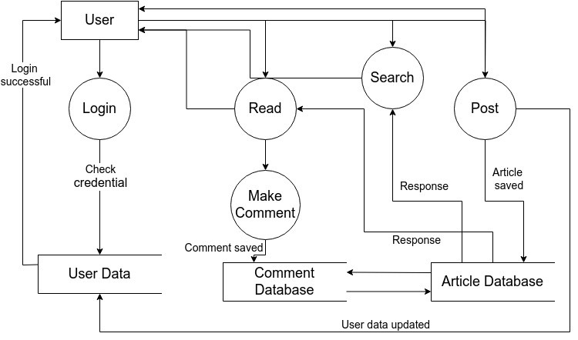

Figure 3-1 Data Flow Diagram

##### Entity Relationship Diagram

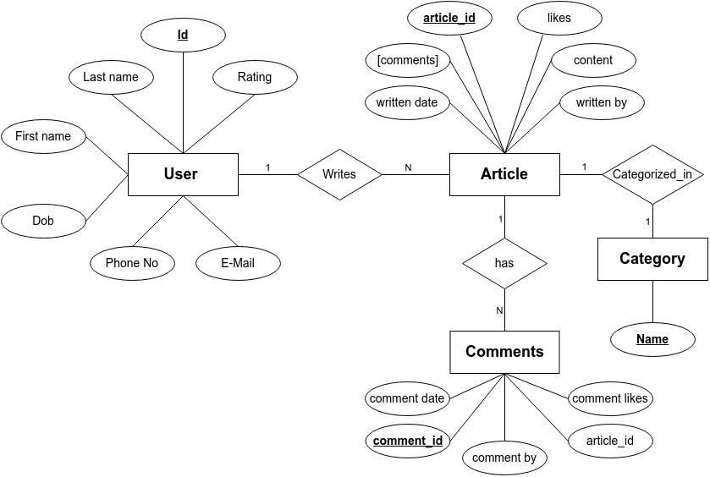

Figure 3-2 ER Diagram

##### UML Activity Diagram

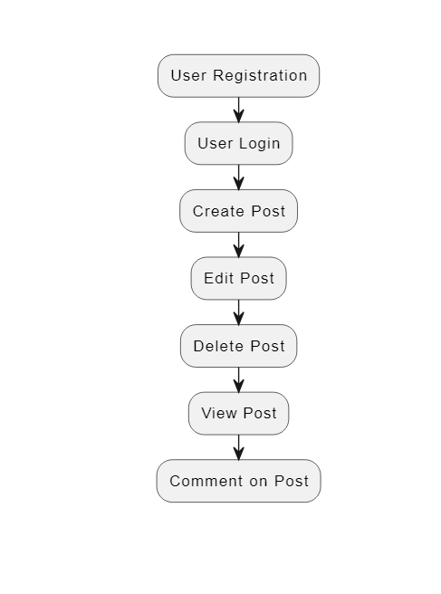

Figure 3-3 UML Activity Diagram

##### UML Use Case Diagram

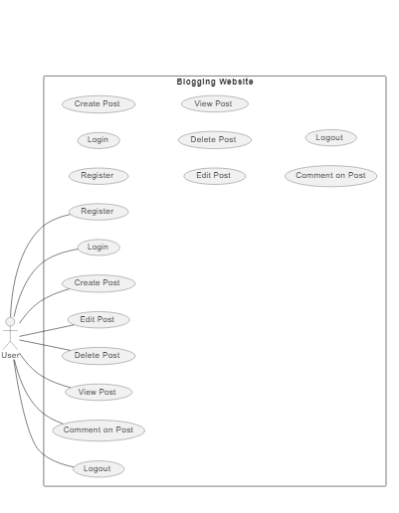

Figure 3-4 UML Use Case Diagram

#### Deployment Requirements

There are various requirements (hardware, software and services) to successfully deploy the system. These are mentioned below :

##### Hardware

1. Intel P4 processor with minimum 2GHz speed.
2. RAM: Minimum 1GB
3. Hard Disk: Min 20GB

##### Software

1. Visual Studio
2. Mysql
3. OS: Window 7/8/10

##### Communication Requirements

Communication between different parts of the system is important since they depend on each other. However, the way in which communication is achieved is not important for the functioning of the system and is therefore handled by the underlined architecture for server and application. User on Intranet will be using HTTP/HTTPS protocol.

## Chapter 4 . Implementation



following a structured implementation plan that encompasses platform development, testing, rollout strategy, training and support, data migration and integration, monitoring and evaluation, and continuous improvement, the Skillforge Education Platform can be successfully implemented and adopted to revolutionize education delivery and management.

#### Technique Used

##### Client Side Scripting / Coding :

Client Side Scripting is the type of code that is executed or interpreted by browsers. It is generally viewable by any visitor to a site (from the view menu click on "View Source" to view the source code).

Below are some common Client Side Scripting technologies:

Below are some common Client Side Scripting technologies:

* HTML (HyperText Markup Language)
* CSS (Cascading Style Sheets)
* JS(JavaScript)

##### Server Side Scripting / Coding:

Server Side Scripting is the type of code that is executed or interpreted by the web server. Server Side Scripting is not viewable or accessible by any visitor or general public.

Below are the common Server Side Scripting technologies:

Node J.S (very common Server Side Scripting language - Linux / Unix based Open Source - free redistribution, usually combines with MySQL database)

#### Tools Used

##### Visual Studio Code:

Since its launch in 2015, Visual Studio Code use has exploded throughout development desktops of all stripes. In its default setup, Visual Studio Code is a text editor first and foremost. However, when coupled with its extension library, it becomes modular and flexible enough to meet any of your development needs. Visual Studio Code, also commonly referred to as VS Code, is a source-code editor made by Microsoft with the Electron Framework, for Windows, Linux and macOS. Features include support for debugging, syntax highlighting, intelligent code completion, snippets, code refactoring, and embedded Git. Users can change the theme, keyboard shortcuts, preferences, and install extensions that add additional functionality.

##### XAMPP:

XAMPP is one of the widely used cross-platform web servers, which helps developers to create and test their programs on a local webserver. It was developed by the Apache Friends,

and its native source code can be revised or modified by the audience. It consists of Apache HTTP Server, MariaDB, and interpreters for the different programming languages like PHP and Perl. It is available in 11 languages and supported by different platforms such as the IA- 32 package of Windows & x64 package of macOS and Linux. XAMPP is a completely free, easy to install Apache distribution containing MariaDB, PHP, and Perl. The XAMPP open source package has been set up to be incredibly easy to install and to use.

**The Apache HTTP Server:** It is a free and open-source cross-platform web server software, released under the terms of Apache License 2.0. Apache is developed and maintained by an open community of developers under the auspices of the Apache Software Foundation.

**SQL:** It is a relational database management system (RDBMS) developed by Oracle that is based on structured query language (SQL). A database is a structured collection of data. It may be anything from a simple shopping list to a picture gallery or a place to hold the vast amounts of information in a corporate network. In particular, a relational database is a digital store collecting data and organizing it according to the relational model. In this model, tables consist of rows and columns, and relationships between data elements all follow a strict logical structure. An RDBMS is simply the set of software tools used to actually implement, manage, and query such a database.

##### 4.2.4 Draw.io

Designed by Seibert Media, draw.io is proprietary software for making diagrams and charts. The software lets you choose from an automatic layout function, or create a custom layout. They have a large selection of shapes and hundreds of visual elements to make your diagram or chart one-of-a-kind. The drag-and-drop feature makes it simple to create a great looking diagram or chart. Draw.io has options for storing saved charts in the cloud, on a server, or network storage at a data center, depending on your needs

#### Language Used

* + 1. **HTML (HyperText Markup Language):** It provides the basic structure of sites, which is enhanced and modified by other technologies like CSS and JavaScript.rather than using a programming language to perform functions, HTML uses tags to identify different types of content and the purposes they each serve to the webpage.Every web page is

made up of a bunch of these HTML tags denoting each type of content on the page. Each type of content on the page is "wrapped" in, i.e. surrounded by, HTML tags.

* + 1. **CSS (Cascading Style Sheets):** It is used to control presentation, formatting, and layout. This programming language dictates how the HTML elements of a website should actually appear on the frontend of the page. Whereas HTML was the basic [structure of your](https://academy.hubspot.com/courses/website-optimization?utm_source=marketing_blog&utm_medium=blog&utm_campaign=website_optimization) [website,](https://academy.hubspot.com/courses/website-optimization?utm_source=marketing_blog&utm_medium=blog&utm_campaign=website_optimization) CSS is what gives your entire website its style. Those slick colors, interesting fonts, and background images? All thanks to CSS. This language affects the entire mood and tone of a web page, making it an incredibly powerful tool -- and an important skill for web developers to learn. It's also what allows websites to adapt to different screen sizes and device types.
    2. **JS(JavaScript) :** It is used to control presentation, formatting, and layout. JavaScript is a logic-based programming language that can be used to modify website content and make it behave in different ways in response to a user's actions. Common uses for JavaScript include confirmation boxes, calls-to-action, and adding new identities to existing information. In short, JavaScript is a programming language that lets web developers design interactive sites.

Most of the dynamic behavior you'll see on a web page is thanks to JavaScript, which augments a browser's default controls and behaviors. Other uses for JavaScript include security password creation, check forms, interactive games, animations, and special effects. It's also used to build mobile apps and create server-based applications. You can add JavaScript to an HTML document by adding these "scripts," or snippets of JavaScript code, into your document's header or body.

* + 1. **Node.js:** A Linux/Unix-based open-source platform, freely redistributable, often used in conjunction with databases like MySQL. Node.js is employed for managing dynamic content, databases, session tracking, and the development of entire e-commerce websites. It boasts support for a variety of key protocols, including POP3, IMAP, and LDAP. Furthermore, Node.js extends its capabilities to include support for Java and distributed object architectures, enabling n-tier development for the first time. Node.js excels in performing system functions, enabling the creation, opening, reading, writing, and closing of files on a system. It proficiently manages data from forms, allowing data to be collected from files, saved to files, sent via email, and returned to users. It facilitates the addition, deletion, and modification of elements within a database using Node.js. Moreover, Node.js can access and set cookie variables. With Node.js, you can implement access restrictions to specific pages of your website and encrypt data..

#### Screenshots

The Following are the screenshots of the result of the project :

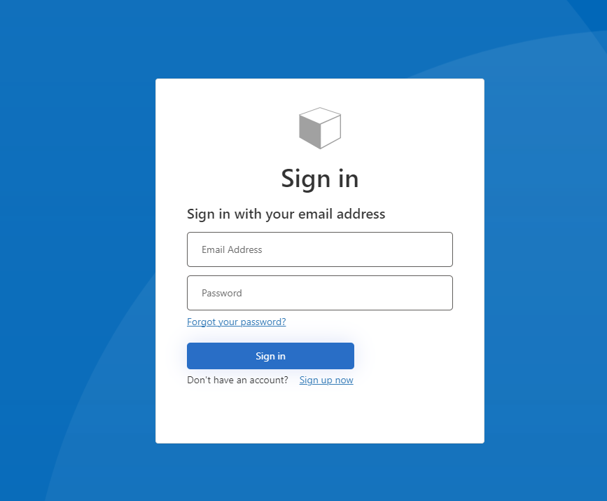

Figure 4-1 First View of WebSite

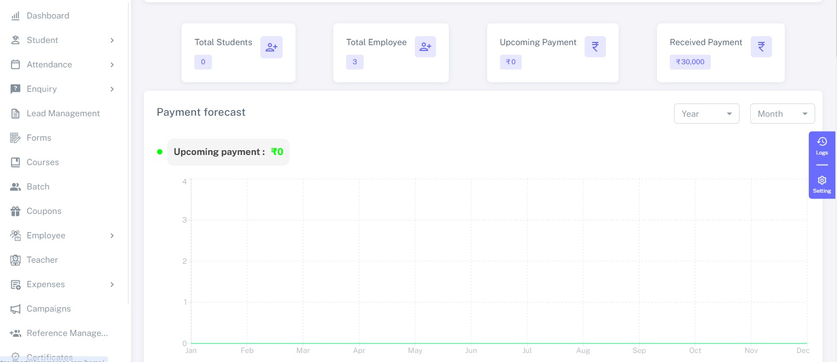

Figure 4-2 Second View of Website

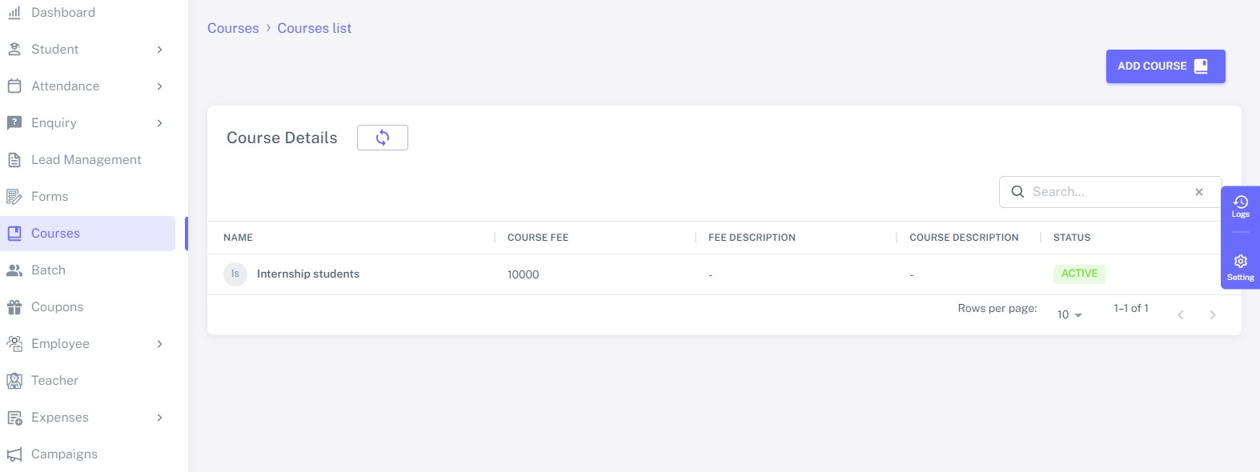

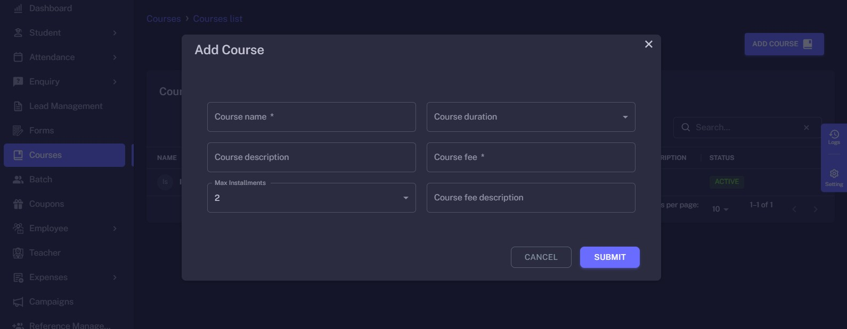

Figure 4-3 Third View of Website



#### Testing

Figure 4-4 Fourth View of Website

Testing is the process of evaluation of a system to detect differences between given input and expected output and also to assess the features of the system. Testing assesses the quality of the product. It is a process that is done during the development process.

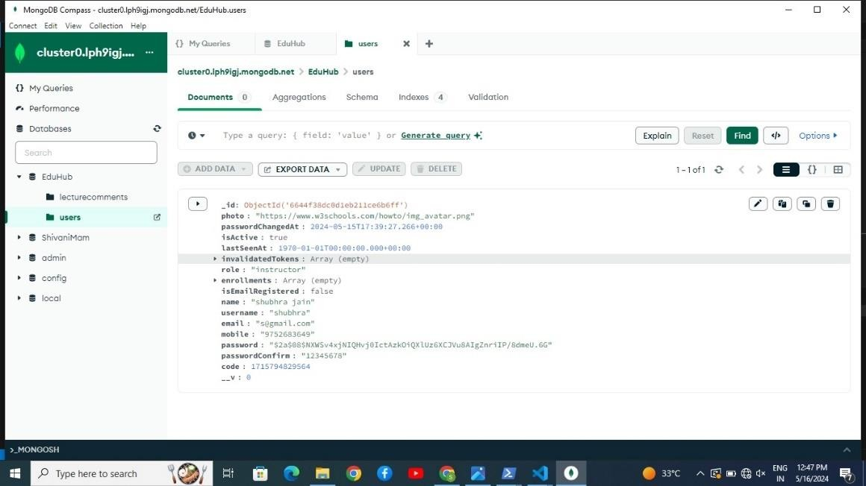

##### Strategy Used

Tests can be conducted based on two approaches –

###### Functionality testing

It is a type of software testing that validates the software system against the functional requirements/specifications. The purpose of Functional tests is to test each function of the software application, by providing appropriate input, verifying the output against the Functional requirements.

###### Implementation testing

The texting method used here is Black Box Testing. It is carried out to test functionality of the program. It is also called „Behavioral‟ testing. The tester in this case, has a set of input values and respective desired results. On providing input, if the output matches with the desired results, the program is tested „ok‟, and problematic otherwise.

##### Test Case and Analysis

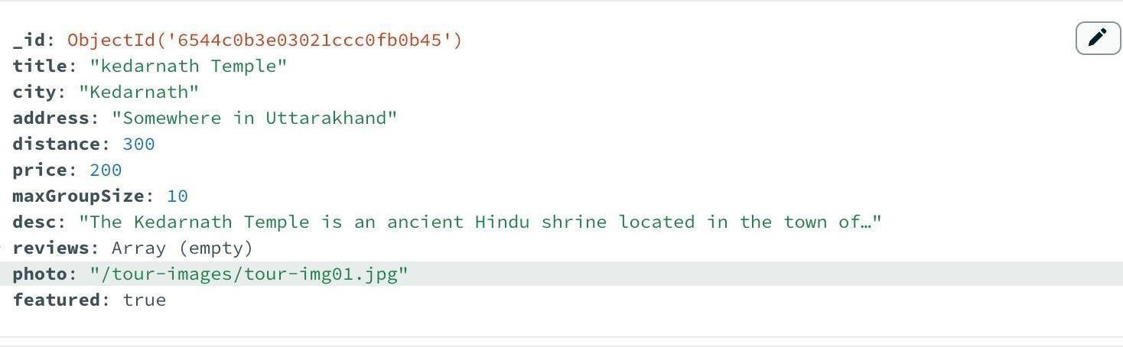

Figure 4-9 Test Case-1

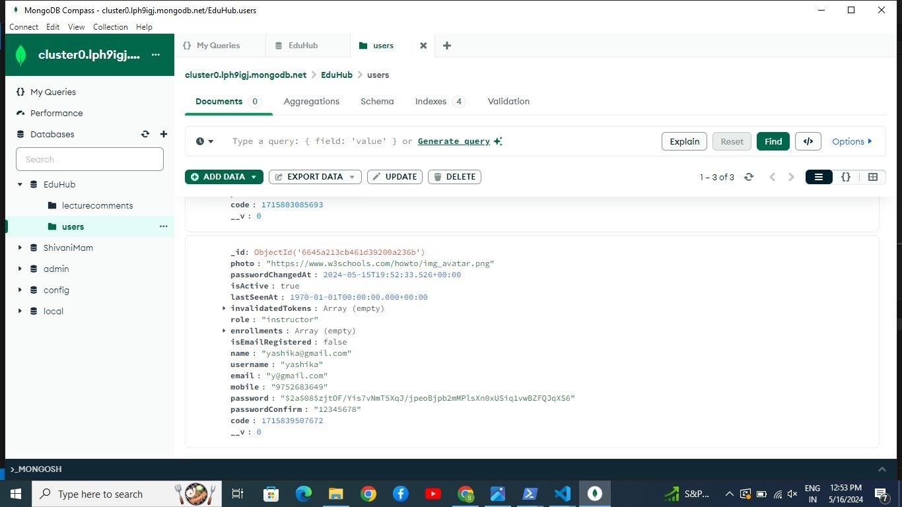

Figure 4-2 Test Case-2

##### Pseudo Code

Start

Initialize Website

Set up a web server

Define routes and endpoints

Handle User Registration and Authentication

* Provide registration and login forms
* Verify user credentials
* Create user accounts and store user data
* Authenticate users and generate tokens

Display Available Tours and Destinations

* Retrieve tour information from a database
* Display tours with details, including name, description, price, and images

Allow Users to Search for Tours

* Provide a search bar for users to enter destination or tour details
* Filter and display tours based on search criteria

Show Tour Details

* Allow users to view detailed information about a specific tour
* Display tour itinerary, duration, cost, and availability

Enable Booking and Reservations

* Allow users to select a tour and specify the number of participants
* Calculate the total cost
* Collect user information for booking
* Store booking details and update tour availability

Provide User Reviews and Ratings

* Display reviews and ratings for tours
* Allow users to submit reviews and ratings
* Calculate and update the overall tour rating

Handle User Profiles

* Allow users to create and update their profiles
* Store user information, preferences, and past bookings

Process Payments

* Accept online payments for tour bookings
* Secure payment processing with payment gateways

Integrate Maps and Location Information

* Display maps and location details for tours and destinations
* Show points of interest and landmarks

Offer Customer Support

* Provide contact information for customer support
* Handle inquiries and support requests

Generate Reports and Analytics

* Collect data on website usage, bookings, and user interactions
* Generate reports for business analysis

Admin Panel

* Create an admin dashboard for managing tours, users, and bookings
* Allow administrators to update content and view reports

End

## Chapter 5. Conclusion



#### Conclusion

In conclusion, the development and implementation of the EduConnect Education Platform represent a significant milestone in the ongoing evolution of education delivery and management. By leveraging innovative technology, user-centered design principles, and best practices in education, EduConnect has the potential to revolutionize the way educators teach and learners engage with educational content.

Through a comprehensive platform that seamlessly integrates curriculum, assessments, communication tools, and analytics, Skillforge empowers educators to deliver personalized learning experiences tailored to the unique needs of their students.

Key Benefits:

1. Streamlining the process of finding accommodations and transportation.
2. Allowing locals and users to register as tourist guides.
3. Providing tourists with insights into local rituals and events, allowing them to participate if interested.
4. Offering an easy and interactive user interface for enhanced user experience.

#### Limitations of the Work

Technological Barriers: The effectiveness of EduConnect relies heavily on access to reliable internet connectivity and compatible devices. In regions with limited infrastructure or resources, access to the platform may be restricted, hindering its impact on underserved communities.

Digital Literacy: EduConnect assumes a certain level of digital literacy among educators, administrators, and learners. However, not all individuals may possess the necessary skills to navigate and utilize the platform effectively. Providing adequate training and support is essential to mitigate this limitation.

Content Relevance and Quality: While EduConnect aims to offer a comprehensive curriculum, the relevance and quality of content may vary across different subjects, grade levels, and regions.

Ensuring alignment with educational standards and engaging diverse stakeholders in content development is crucial to address this limitation.

#### Suggestion and Recommendations for Future Work

This project presents multiple opportunities for enhancement, with the potential to introducevarious new features to the application. One of these features is an online guide system, where users' locations are detected, and they receive real-time assistance through our website. We're planning to introduce interactive elements, such as video calls with guides who can provide in- depth information about the locations. Additionally, a user review-based rating system for places will be incorporated. In the future, we aim to continuously improve the application to raise the industry standards and enhance the user experience.

**BIBLIOGRAPHY**

[1]. <https://smartclasses.in/login>

[2]. [https://www.karomanage.com](https://www.karomanage.com/) [3].<https://www.tripadvisor.in/> [4][.https://www.irctctourism.com](https://www.irctctourism.com/)/ [5].[https://tourism.mp.gov.in/](https://tourism.mp.gov.in/contents?page=registered-homestay&number=2wyUbp51NyrP3L%2BlLhjGaQ%3D%3D)

[6].<https://tourism.mp.gov.in/mptbproperty/Modules/Info/frm_HomeStay.aspx>

[7.**]**[**Subrat Sahu,**](https://www.researchgate.net/profile/Subrat-Sahu)[**Kavita Chavali..**](https://www.researchgate.net/profile/Kavita-Chavali-2) **Comparative Study of Tourism Websites in India - With special reference to South India.**

1. **Azdine El Maazouzi. The Impact of Official Tourism Website on the Destination Image.**
2. **Deepanjal Shreshtha, Tan Wenan, Nisha Rajkarnikar, Deepmala Shreshtha, Seung Ryul Jeong. Study and Evaluation of Tourism Websites based on User Perspective.**
3. [**Richard W. Butler.**](https://www.researchgate.net/profile/Richard-Butler) **The Evolution of Tourism and Tourism Research.**